
USP
UNIVERSITY OF THE SOUTH PACIFIC

Pacific Institute of Advanced Studies
In Development and Governance (PIAS-DG)
_________________________

PCRC
PACIFIC CONCERNS RESOURCE CENTRE Inc.

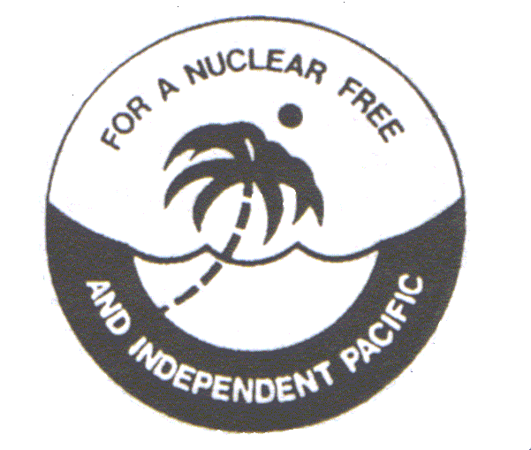

Invite you all to a, PUBLIC LECTURE
Co-sponsored by the Pacific Institute of Advanced Studies in Development and Governance and Pacific Concerns Resource Centre Inc

DECOLONISATION

Speaker 1: Dr.Carlyle Corbin,
“The role of the United Nations in Decolonization Process”
Dr.Carlyle Corbin is an Independent Expert on Governance. He is from the US Virgin Islands in the Caribbean.

Speaker 2: Dr. John Ondawame,
“The difficulty of re-inscription in order to be given the due process of Decolonization,
the case of West Papua.
Dr. John Ondawame is a full time campaigner for West Papua and based at the West Papuan Peoples Representative Office in Port Vila, Republic of Vanuatu. He is also the Spolesman for the West Paapuan Independence Movement, the OPM. He holds a Ph.D from ANU.

Date: 27 November 2006 Time: 5.30 – 7.00 pm
Venue: Lecture Room S024 Faculty of Business and Economics, USP (former SSED Building).

For further information: Rex Rumakiek on Tel. 3304649, Mobile: 9344436
Dolores Joseph, Tel. 3232764 or
Susan Tavuna’i-Mani, Tel. 3232661
Email: joseph_d@usp.ac.fj

